

SUBJECT:

WEB And OPEN SOURCE TECHNOLOGIES(WOT)

SUBMITTED TO:

Mr. NAND KISHORE

IT Department UIET-PU

SUBMITTED BY:

VISHU CHHABRA

IT Section -A, Group -1, Year -2

Roll No -UE189086 (Branch Slider)

Practical:1

AIM: Introduction to HTML, Define structure of html. Define basic tags of html and their properties.

History

**HTML** stands for **Hyper Text Mark-up Language**, which is the most widely used language on Web to develop web pages. **HTML** was created by Berners-Lee in late 1991 but "HTML 2.0" was the first standard HTML specification which was published in 1995. HTML 4.01 was a major version of HTML and it was published in late 1999. Though HTML 4.01 version is widely used but currently we are having HTML-5 version which is an extension to HTML 4.01, and this version was published in 2012.

Basic Structure of HTML

Before you can start adding content to your document, there's a basic structure you need to set up in your file. This structure isn't only required for your document to be compliant but will also allow you to provide useful information about your document. The basic structure of any HTML document consists of the following sections or elements:

* The DTD (!DOCTYPE declaration).
* The main container ([html element](https://www.htmlquick.com/reference/tags/html.html)).
* The head section ([head element](https://www.htmlquick.com/reference/tags/head.html)).
* The body section ([body element](https://www.htmlquick.com/reference/tags/body.html)).

It is also shown in following html code:

<!DOCTYPE html>

<html>

<head>

<title>This is document title</title>

</head>

<body>

<h1>This is a heading</h1>

<p>Hello World!</p>

</body>

</html>

Basic Tags in HTML

1. HTML Headings:

HTML headings are defined with the <h1> to <h6> tags.

<h1> defines the most important heading. <h6> defines the least

important heading.

2. Image Tag:

The <img> tag is used to embed an image in an HTML page.

Images are not technically inserted into a web page; images are linked to web pages. The <img> tag creates a holding space for the referenced image.

The <img> tag has two required attributes:

* src - Specifies the path to the image
* alt - Specifies an alternate text for the image, if the image for some reason cannot be displayed

3.Anchor Tag:

The <a> tag defines a hyperlink, which is used to link from one page to

another.

The most important attribute of the <a> element is the href attribute,

which indicates the link's destination.

By default, links will appear as follows in all browsers:

* An unvisited link is underlined and blue
* A visited link is underlined and purple
* An active link is underlined and red

4.Marquee Tag:

The <marquee> is a non-standard HTML tag which was used to create a scrolling text or an image.

It was used to make the text or image scroll horizontally across or vertically down the web page. Because of its usability problems it was often compared with [Netscape’s blink element](https://en.wikipedia.org/wiki/Netscape_(web_browser)).

Program: <https://github.com/vishuchhabra/Web_lab/blob/master/Experiments_web_lab/practical1.html>

Output:

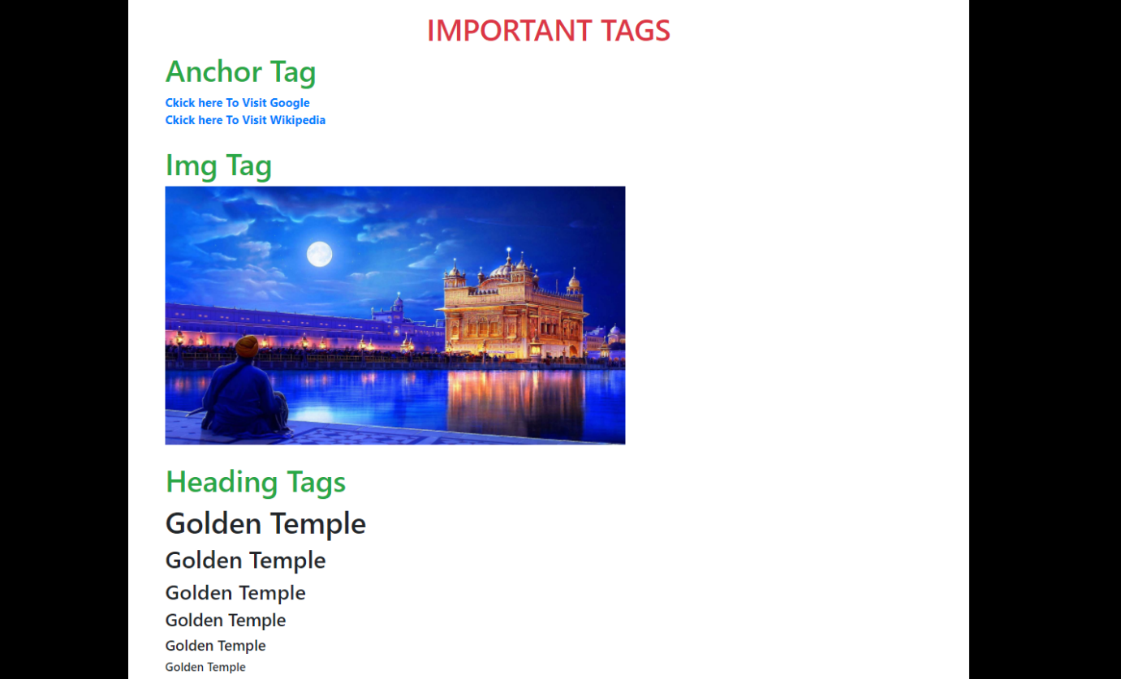

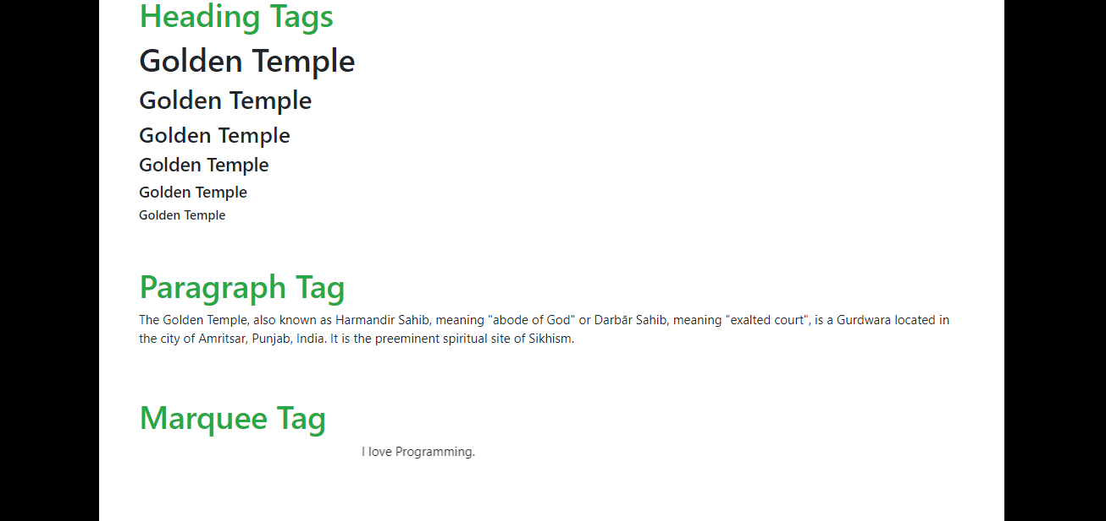

Practical:2

AIM: Explain Ordered List and Unordered List, nested List with attributes and Explanation.

Explanation:

**Ordered HTML List**

An ordered list starts with the <ol> tag. Each list item starts with the <li> tag.

The list items will be marked with numbers by default.

**Unordered HTML List**

An unordered list starts with the <ul> tag. Each list item starts with the <li> tag.

The list items will be marked with bullets (small black circles) by default.

Program:

<https://github.com/vishuchhabra/Web_lab/blob/master/Experiments_web_lab/practical2.html>

Output:

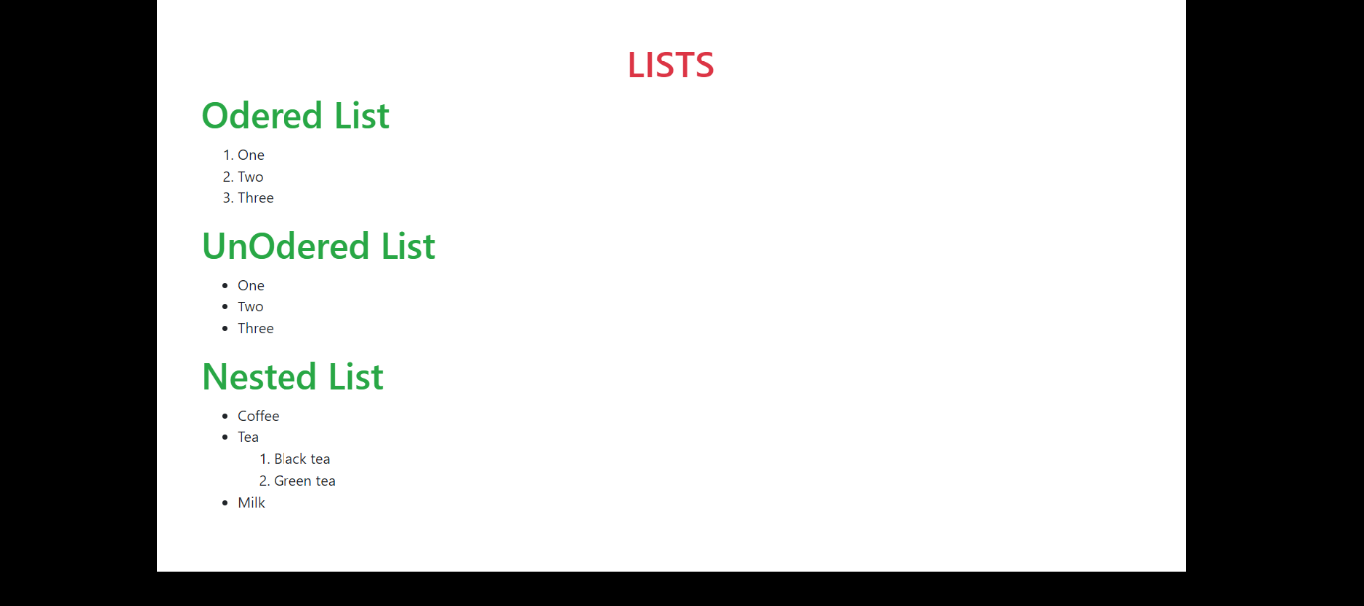

Practical:3

AIM: Explain Basic Table Tag in html. Also, explain rowspan, colspan and draw Lab Time table.

Explanation:

**Table Tag:**

The <table> tag defines an HTML table.

An HTML table consists of one <table> element and one or more [<tr>](https://www.w3schools.com/tags/tag_tr.asp), [<th>](https://www.w3schools.com/tags/tag_th.asp), and [<td>](https://www.w3schools.com/tags/tag_td.asp) elements.

The <tr> element defines a table row, the <th> element defines a table header, and the <td> element defines a table cell.

An HTML table may also include [<caption>](https://www.w3schools.com/tags/tag_caption.asp), [<colgroup>](https://www.w3schools.com/tags/tag_colgroup.asp), [<thead>](https://www.w3schools.com/tags/tag_thead.asp), [<tfoot>](https://www.w3schools.com/tags/tag_tfoot.asp), and [<tbody>](https://www.w3schools.com/tags/tag_tbody.asp) elements.

**Rowspan:**

The rowspan attribute specifies the number of rows a cell should span.

**Colspan:**

The colspan attribute defines the number of columns a cell should span.

**Cell Padding:**

The cell padding is used to define the spaces between the cells and its border. If cell padding property is not applying then it will be set as default value.

**Cell Spacing**

The cell spacing is used to define the space between the cells.

Program:

<https://github.com/vishuchhabra/Web_lab/blob/master/Basic%20files/p4.html>

<https://github.com/vishuchhabra/Web_lab/blob/master/Experiments_web_lab/practical3.html>

Output:

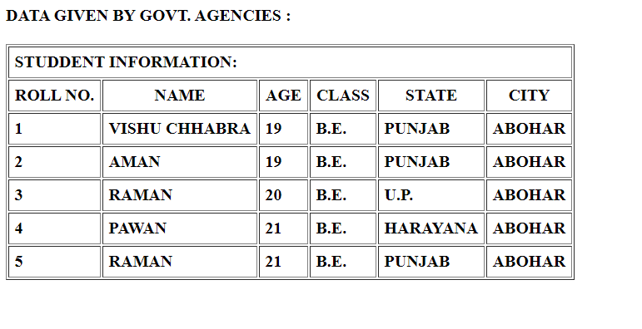

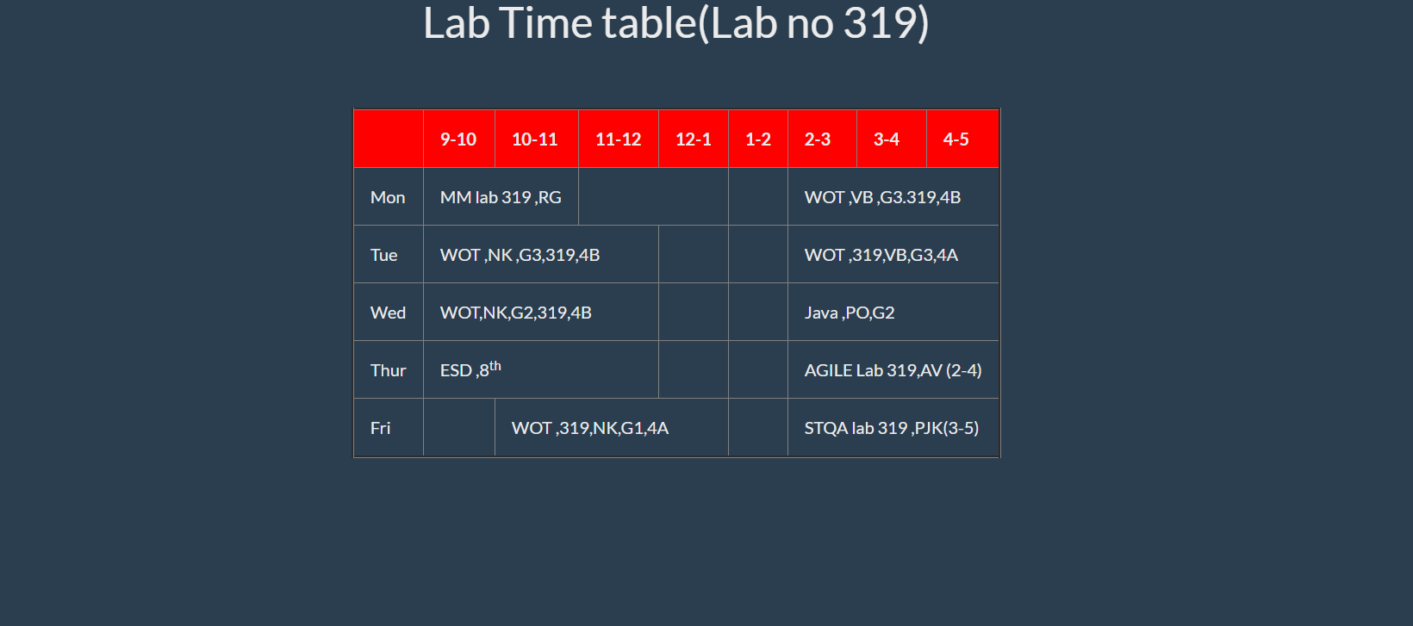

Practical:4

AIM: Explain CSS box model with designing and also explain div, span, and CSS selectors.

Explanation:

**The CSS Box Model**

All HTML elements can be considered as boxes. In CSS, the term "box model" is used when talking about design and layout.

The CSS box model is essentially a box that wraps around every HTML element. It consists of: margins, borders, padding, and the actual content. The image below illustrates the box model:

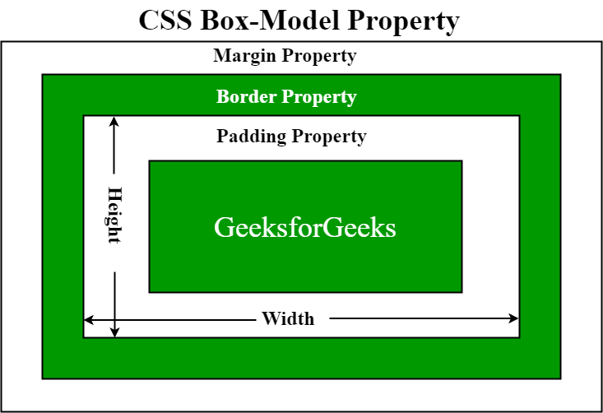

Explanation of the different parts:

* **Content** - The content of the box, where text and images appear
* **Padding** - Clears an area around the content. The padding is transparent
* **Border** - A border that goes around the padding and content
* **Margin** - Clears an area outside the border. The margin is transparent

The box model allows us to add a border around elements, and to define space between elements.

Program:

|  |
| --- |
| <!DOCTYPE html> |
| <html> |
| <head> |
| <style> |
| div { |
| background-color: lightgrey; |
| width: 300px; |
| border: 15px solid green; |
| padding: 50px; |
| margin: 20px; |
| } |
| </style> |
| </head> |
| <body> |
|  |
| <h2>Demonstrating the Box Model</h2> |
|  |
| <p>The CSS box model is essentially a box that wraps around every HTML element. It consists of: borders, padding, margins, and the actual content.</p> |
|  |
| <div>This text is the content of the box. We have added a 50px padding, 20px margin and a 15px green border. Ut enim ad minim veniam, quis nostrud exercitation ullamco laboris nisi ut aliquip ex ea commodo consequat. Duis aute irure dolor in reprehenderit in voluptate velit esse cillum dolore eu fugiat nulla pariatur. Excepteur sint occaecat cupidatat non proident, sunt in culpa qui officia deserunt mollit anim id est laborum.</div> |
|  |
| </body> |
| </html> |

Output:

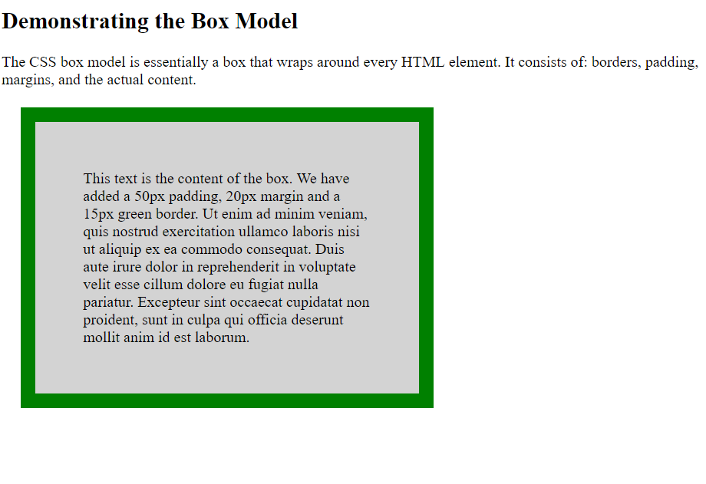

**Div Tag:**

The <div> tag defines a division or a section in an HTML document.

The <div> tag is used as a container for HTML elements - which is then styled with CSS or manipulated with JavaScript.

The <div> tag is easily styled by using the class or id attribute.

Any sort of content can be put inside the <div> tag!

**Span Tag:**

The <span> tag is an inline container used to mark up a part of a text, or a part of a document.

The <span> tag is easily styled by CSS or manipulated with JavaScript using the class or id attribute.

The <span> tag is much like the [<div>](https://www.w3schools.com/tags/tag_div.asp) element, but <div> is a block-level element and <span> is an inline element.

**CSS Selectors**

CSS selectors are used to "find" (or select) the HTML elements you want to style.

We can divide CSS selectors into five categories:

* Simple selectors (select elements based on name, id, class)
* [Combinator selectors](https://www.w3schools.com/css/css_combinators.asp) (select elements based on a specific relationship between them)
* [Pseudo-class selectors](https://www.w3schools.com/css/css_pseudo_classes.asp) (select elements based on a certain state)
* [Pseudo-elements selectors](https://www.w3schools.com/css/css_pseudo_elements.asp) (select and style a part of an element)
* [Attribute selectors](https://www.w3schools.com/css/css_attribute_selectors.asp) (select elements based on an attribute or attribute value)

**The CSS element Selector**

The element selector selects HTML elements based on the element name.

**The CSS id Selector**

The id selector uses the id attribute of an HTML element to select a specific element.

The id of an element is unique within a page, so the id selector is used to select one unique element!

To select an element with a specific id, write a hash (#) character, followed by the id of the element.

## **The CSS class Selector**

The class selector selects HTML elements with a specific class attribute.

To select elements with a specific class, write a period (.) character, followed by the class name.

**The CSS Universal Selector**

The universal selector (*) selects all HTML elements on the page.

**The CSS Grouping Selector**

The grouping selector selects all the HTML elements with the same style definitions.

Look at the following CSS code (the h1, h2, and p elements have the same style definitions):

Practical:5

AIM: Explain Frameset, Frame Tags and load HTML document.

Explanation:

**Frameset and Frame:**

HTML frames are used to divide your browser window into multiple sections where each section can load a separate HTML document. A collection of frames in the browser window is known as a frameset. The window is divided into frames in a similar way the tables are organized: into rows and columns.

**Creating Frames**

To use frames on a page we use <frameset> tag instead of <body> tag. The <frameset> tag defines, how to divide the window into frames. The **rows** attribute of <frameset> tag defines horizontal frames and **cols** attribute defines vertical frames. Each frame is indicated by <frame> tag and it defines which HTML document shall open into the frame.

Loading html pages through Frame and Frameset is following as:

Program:

<https://github.com/vishuchhabra/Web_lab/blob/master/Experiments_web_lab/practical5.html>

Output:

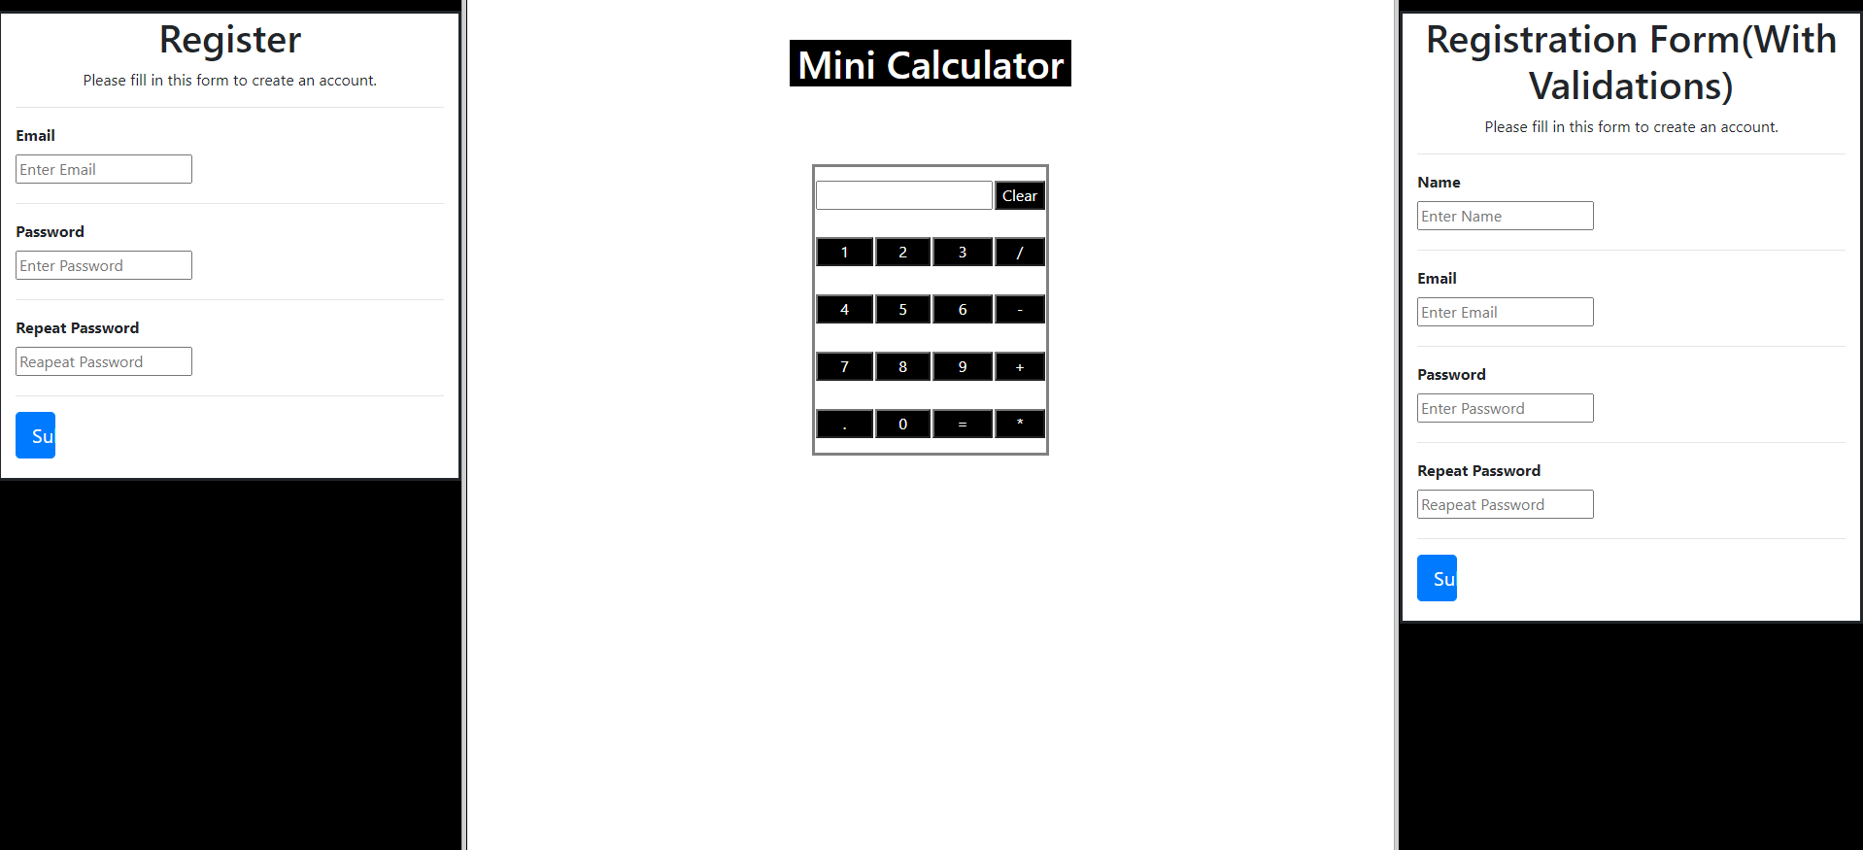

Practical:6

AIM: Design user registration form in html. Also explain about this tag.

Explanation:

The <form> tag is used to create an HTML form for user input.

The <form> element can contain one or more of the following form elements:

* [<input>](https://www.w3schools.com/tags/tag_input.asp)
* [<textarea>](https://www.w3schools.com/tags/tag_textarea.asp)
* [<button>](https://www.w3schools.com/tags/tag_button.asp)
* [<select>](https://www.w3schools.com/tags/tag_select.asp)
* [<option>](https://www.w3schools.com/tags/tag_option.asp)
* [<optgroup>](https://www.w3schools.com/tags/tag_optgroup.asp)
* [<fieldset>](https://www.w3schools.com/tags/tag_fieldset.asp)
* [<label>](https://www.w3schools.com/tags/tag_label.asp)
* [<output>](https://www.w3schools.com/tags/tag_output.asp)

Program:

<https://github.com/vishuchhabra/Web_lab/blob/master/Experiments_web_lab/practical6.html>

Output:

Registration form without validations

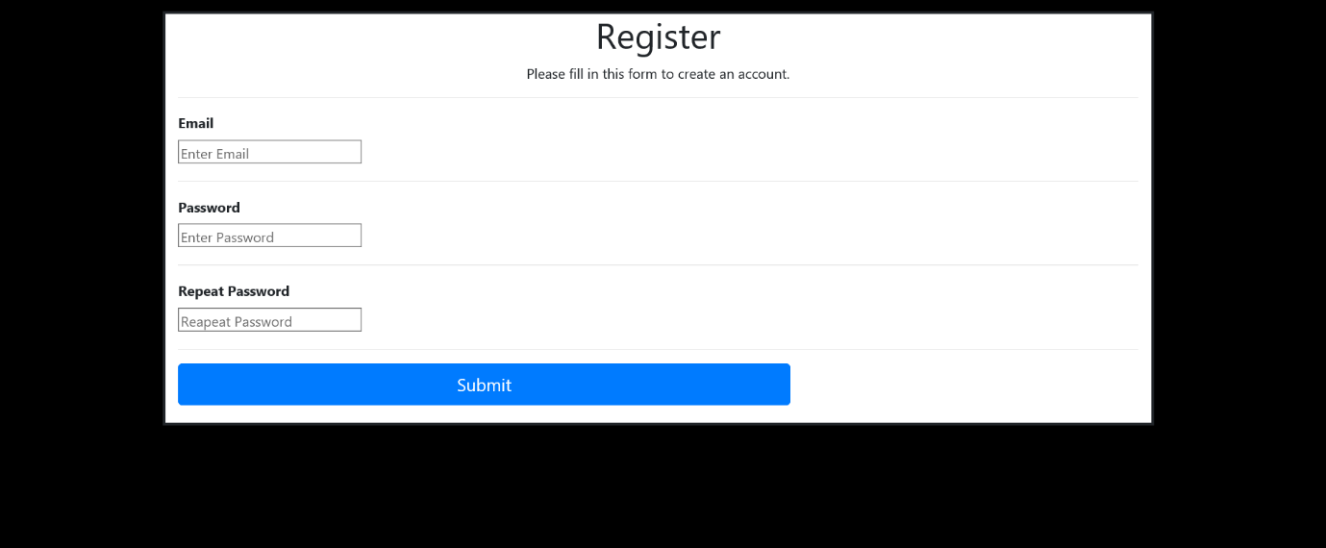

Practical:7

AIM: Design Alert box, confirm box and prompt box and html.

Explanation:

**Alert Box**

An alert box is often used if you want to make sure information comes through to the user.

When an alert box pops up, the user will have to click "OK" to proceed.

**Confirm Box**

A confirm box is often used if you want the user to verify or accept something.

When a confirm box pops up, the user will have to click either "OK" or "Cancel" to proceed.

If the user clicks "OK", the box returns **true**. If the user clicks "Cancel", the box returns **false**.

**Prompt Box**

A prompt box is often used if you want the user to input a value before entering a page.

When a prompt box pops up, the user will have to click either "OK" or "Cancel" to proceed after entering an input value.

If the user clicks "OK" the box returns the input value. If the user clicks "Cancel" the box returns null.

Program:

<https://github.com/vishuchhabra/Web_lab/blob/master/Experiments_web_lab/practical7.html>

Output:

Basic three buttons for all three types of pop ups

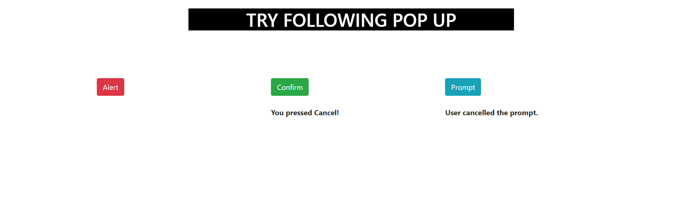

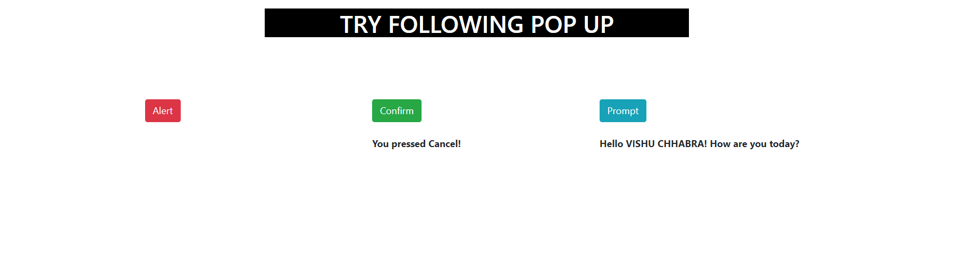

Practical:8

AIM: Change the content of html document using DOM. Also explain DOM and DOM properties.

Explanation:

**DOM (Document Object Model)**

In this post, we will discuss Document Object Model (DOM) along with its properties and methods used to manipulate Document.

**Introduction**:

The Document Object Model (DOM) is a ***programming interface*** for **HTML** and **XML** (Extensible mark-up language) documents. It defines the **logical structure** of documents and the way a document is accessed and manipulated.

**Note**: It is called as a Logical structure because DOM doesn’t specify any relationship between objects.

DOM is a way to represent the webpage in the structured hierarchical way so that it will become easier for programmers and users to glide through the document. With DOM, we can easily access and manipulate tags, IDs, classes, Attributes or Elements using commands or methods provided by Document object.

**Structure of DOM**:

DOM can be thought of as Tree or Forest (more than one tree). The term **structure model**is sometimes used to describe the tree-like representation of a document. One important property of DOM structure models is ***structural isomorphism***: if any two DOM implementations are used to create a representation of the same document, they will create the same structure model, with precisely the same objects and relationships.

**Why called as Object Model?**

Documents are modelled using objects, and the model includes not only the structure of a document but also the behaviour of a document and the objects of which it is composed of like tag elements with attributes in HTML.

**Properties of DOM**:

Let’s see the properties of document object that can be accessed and modified by the document object.  


1. **Window Object:** Window Object is at always at top of hierarchy.
2. **Document object:** When HTML document is loaded into a window, it becomes a document object.
3. **Form Object:** It is represented by **form** tags.
4. **Link Objects:** It is represented by **link**tags.
5. **Anchor Objects:** It is represented by **a href** tags.
6. **Form Control Elements:** Form can have many control elements such as text fields, buttons, radio buttons, and checkboxes, etc.

Program:

<https://github.com/vishuchhabra/Web_lab/blob/master/Experiments_web_lab/practical8.html>

Output:

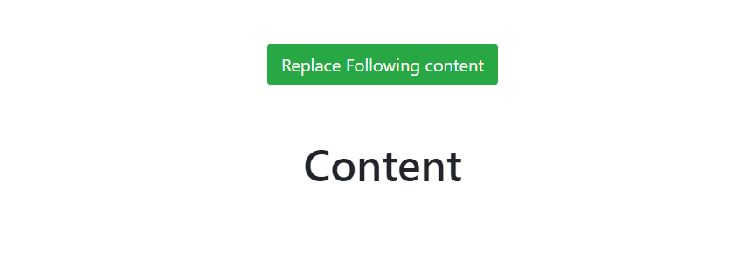

After changing the content by prompt box.



Practical:9

AIM: Design calculator in Java script.

Program:

<https://github.com/vishuchhabra/Web_lab/blob/master/Experiments_web_lab/practical9.html>

Output:

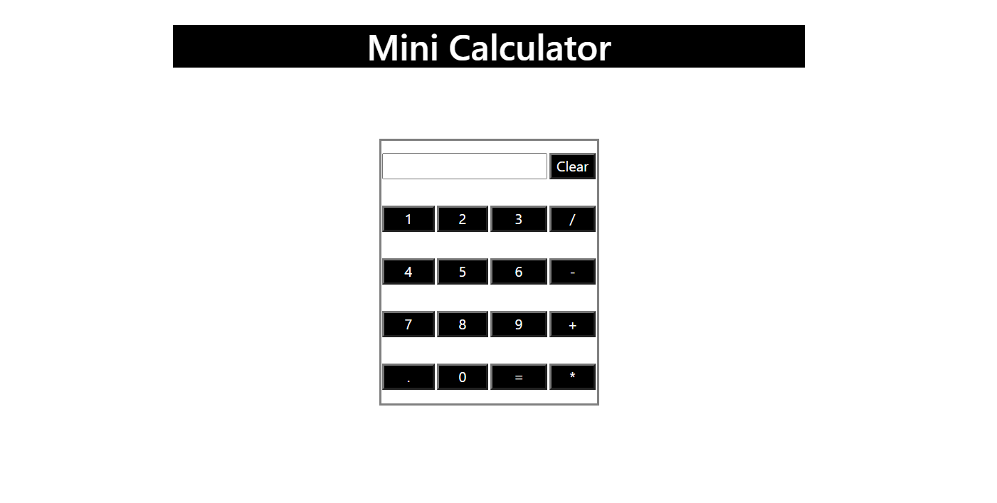

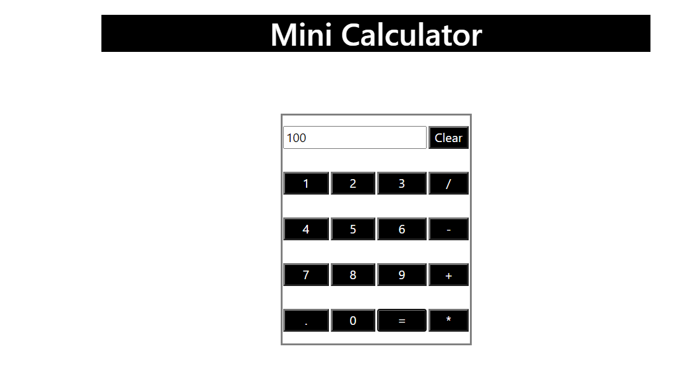

Practical:10

AIM: Design Validation form in java script.

Program:

<https://github.com/vishuchhabra/Web_lab/blob/master/Experiments_web_lab/practical10.html>

Output:

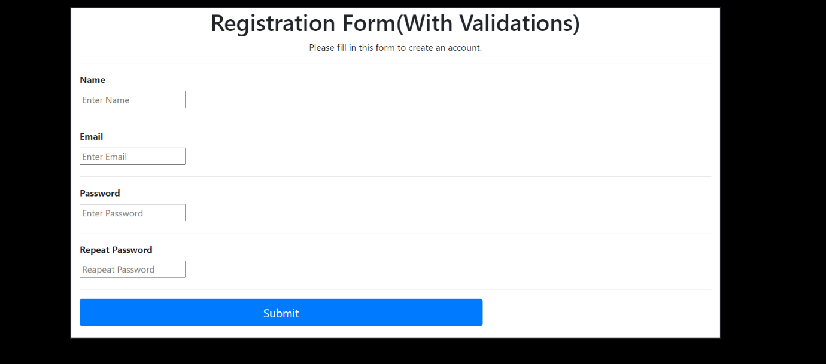

Practical:11

AIM: Installation PHP and create Simple web Page.

Explanation:

**Manually installing PHP on Windows**

Installing PHP on a Windows 10 machine is no at all difficult. First of all let’s understand the steps involved and after that, we will go through each step in detail.

1. First, we will do the latest PHP package from the [PHP website](https://www.php.net/downloads.php).
2. Once we have the zip file, we will create a PHP7 folder in the C drive and extract the contents of the zip file in this folder.
3. Make some changes in the PHP.ini file.
4. Change the path environment variable.

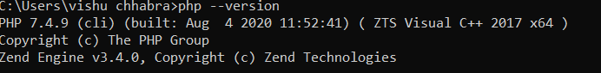

Install XAMPP on window and start the server.

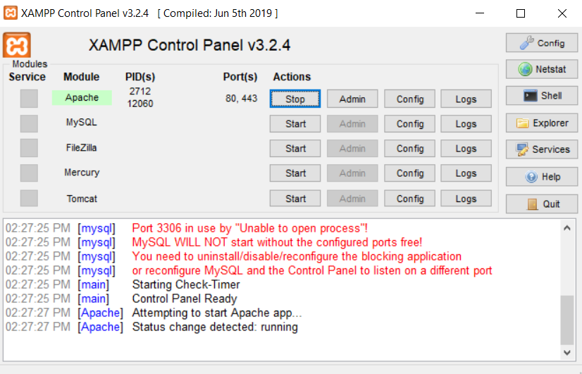

Program:

<https://github.com/vishuchhabra/Web_lab/blob/master/Experiments_web_lab/practical11.php>

Output After starting the server is shown as following:

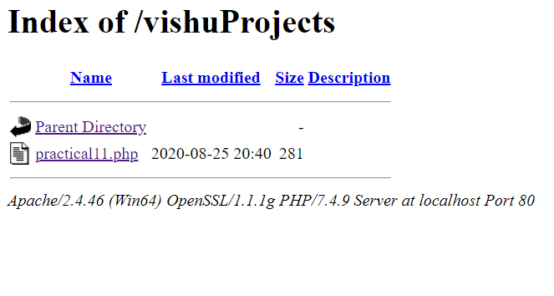

Running my first simple php app on localhost

